**Project Design Phase-I**

**Solution Architecture**

|  |  |
| --- | --- |
| Date | 2022-10-17 |
| Team ID | PNT2022TMID39941 |
| Project Name | Project – Smart Solution for Railway |
| Maximum Marks | 4 Marks |

**Solution Architecture:**

Solution architecture is a complex process – with many sub-processes - technology solutions. Its goals are to:

* Smart trains refer to the intelligentization of railway mobile mobile transport equipment.
* Provide specifications according to which the solution is defined, managed, and delivered.
* The complete Big data architecture includes computing devices.
* It combines Software products to make more intelligent use of rail assets from track of train.

**Example - Solution Architecture Diagram:**

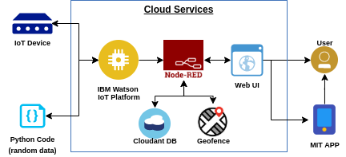

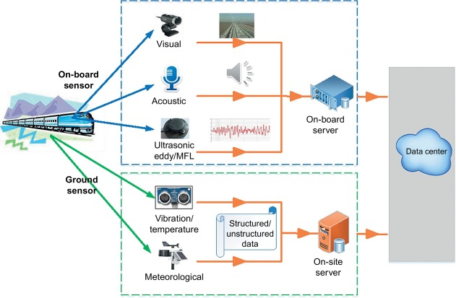

Figure 1: Architecture and data flow of the voice patient diary sample application

**Reference:** [**https://aws.amazon.com/blogs/industries/voice-applications-in-clinical-research-powered-by-ai-on-aws-part-1-architecture-and-design-considerations/**](https://aws.amazon.com/blogs/industries/voice-applications-in-clinical-research-powered-by-ai-on-aws-part-1-architecture-and-design-considerations/)